A Guide to Formatting Your Manuscript
The way in which you format your manuscript is nearly as important as the writing itself. A well-formatted manuscript allows our production team to clearly discern how your text is to be laid out and ensures your students will receive a highly organized, easy-to-understand book.
Because quality formatting is so crucial to our layout and production processes, we ask all Cognella authors to use Microsoft Word Styles when writing and formatting manuscripts. This guide will walk you through how to find and apply styles in Word, how to customize styles, and how to use other Word features to help with formatting your manuscript. Additionally, your project editor will provide you a Microsoft Word Styles template you can use to begin writing your book.
If you’ve never used Microsoft Word Styles before, you’ll be pleasantly surprised to discover how easy the Microsoft Word feature makes writing a fully formatted manuscript. Styles eliminate the need to toggle back and forth within Word to repeatedly change the font, size, or color of text in each section of your manuscript. You can simply set and apply Word Styles to do the work for you, saving you time and ensuring consistency throughout your manuscript.
Ready to learn about Microsoft Word Styles? First, let’s explore where to find them.

Finding the Word Styles Group
You’ll likely include headings, lists, key words, and block quotes within your manuscript. Microsoft Word provides specific styles for each of these manuscript features, which can be found by clicking the Home tab and locating the Styles group.

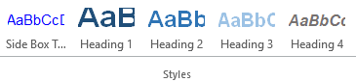

If you click Home, but do not see a Styles group in your toolbar similar to the one pictured above, it’s likely due to the version of Microsoft Word you have downloaded on your computer. If you cannot find the Styles group in your version of Word, contact your project editor for further assistance.
Now, let’s take a look at some commonly used styles and how they can be incorporated within your manuscript.

Type 1: Headings

Importance of Defining Levels of Headings
Selecting strategic places within your manuscript to break up text and place headings is one of the most important parts of organizing your text. It’s also important to format headings consistently throughout your document. If you don’t, our production team may not be able to differentiate between headings and subheadings to properly organize your book.
Luckily, Microsoft Word Styles can help. You can use default heading options, found in the Styles group, to easily organize your content:
Use Heading 1 for main headings, Heading 2 for a subtopic beneath your main heading, and Heading 3 for a subtopic of Heading 2. Do not use Heading 4 or beyond. This will ensure the hierarchy of your manuscript is clear. More than four levels of headings outlined in your table of contents can get quite messy.
If you have any questions regarding your hierarchy of topics and the use of headings, contact your project editor.

Applying Heading Styles
When you click on the various headings found throughout this document, the corresponding heading style will appear outlined by a colored box in the Styles group in the toolbar. If you click the arrow in the lower right-hand corner of the Styles group, a list of styles will appear. The style of the heading selected within the document will be outlined by a colored box within the list.
In the image below, you can see the first heading in this guide uses the Heading 1 style.

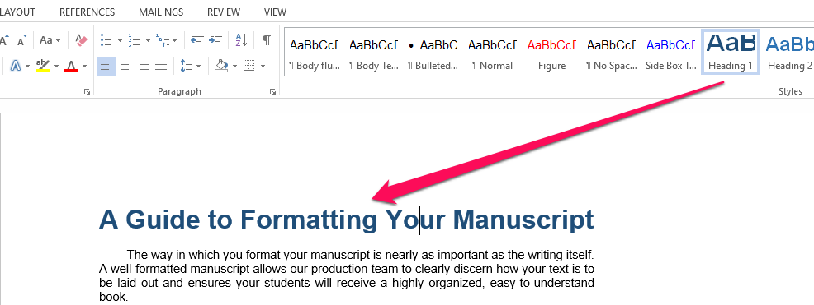

Similarly, the second heading in this document uses the Heading 2 style.

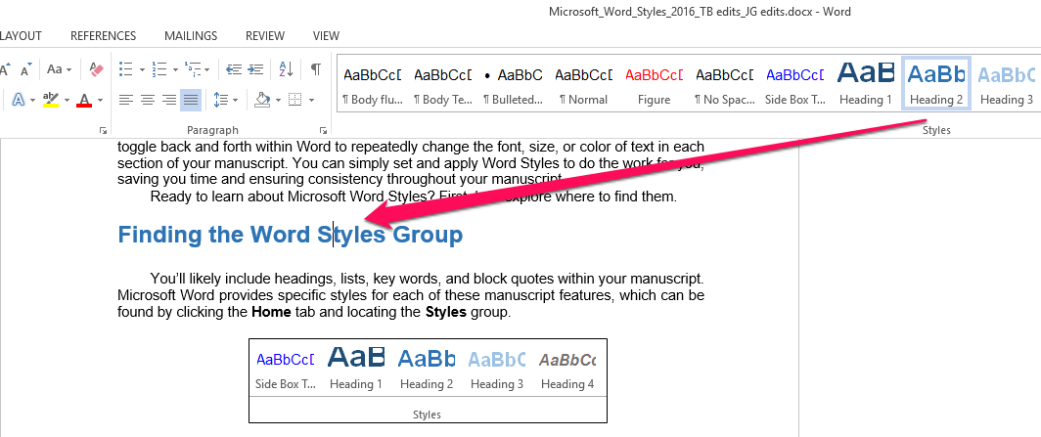

When you place your cursor within a line of text and click on a particular style in the Styles group, the text will reformat according to the style selected.
As you format your manuscript, apply styles to headings based on content hierarchy.

Type 2: Normal
The most basic paragraph style is the Normal style. A Normal style paragraph (in this guide) includes an indent in the first line of text, no extra spacing between paragraphs, and justified text.
You can customize the Normal style to fit your needs and preferences. To adjust this style, type and format a paragraph (including font type and size) in Word as you normally would—without the help of a particular Microsoft Word Style. Highlight the full paragraph, right-click on the Normal style button in the toolbar, and select Update Normal to Match Selection, as shown in the image below. Your newly updated Normal style will reflect the text you customized yourself, and you can apply this style throughout your document.

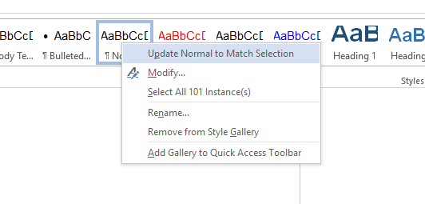

Type 3: Bulleted and Numbered Lists
Microsoft Word provides a feature that allows you to easily and effectively build a list within your manuscript. Whether you want to create single-level bulleted and numbered lists or multi-level hierarchy lists, Microsoft Word has you covered. By using this feature, you can clearly indicate to our production team where to include bulleted or numbered lists within your book.
Microsoft Word provides a set of list options under the Home tab in the Paragraph group, as shown below.

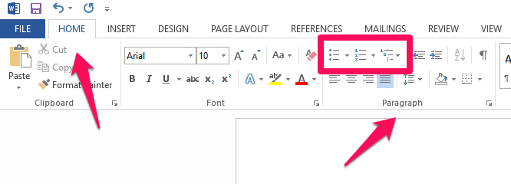

The default options allow you to create (from left to right) simple bulleted lists, numbered or lettered lists, and more complicated combinations of list levels. To build out more complicated lists, click the arrow to the right of each icon for more selections, as shown below.

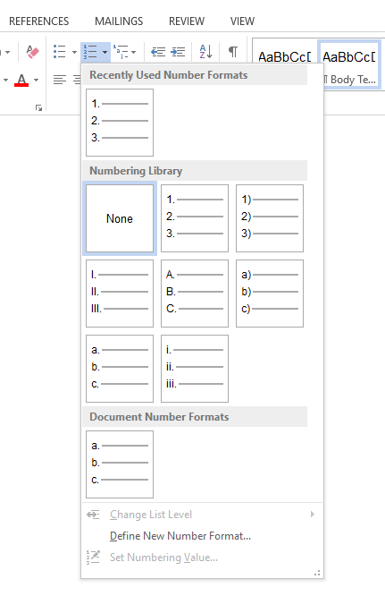

Here is an example of a numbered list that has two levels (Microsoft Word allows up to nine). If you click anywhere in the typed list below, the numbered list icon will appear highlighted in the toolbar above.

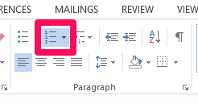

- This is the first item at level one.
  - This is the first item at level two, within the first item at level one.
  - This is the second item at level two, within the first item at level one.
- This is the second item at level one.
  - This is the first item at level two, within the second item at level one.
- This is the third item at level one.
  - This is the first item at level two, within the third item at level one.
  - This is the second item at level two, within the third item at level one.

Type 4: Character Styles (for key words)
Character styles apply emphasis to key words in your text. Microsoft Word Styles provides a set of character styles that include subtle emphasis, emphasis, intense emphasis, and strong. If you place your cursor within any of the emphasized words in this paragraph, the corresponding style will appear outlined in the Styles group in the toolbar.
Using one of these styles to emphasize key words throughout your manuscript is not necessary, but it does help our production team by giving them the option to reformat all key words at once, simplifying and enhancing the manuscript design process.
To apply a character style, highlight or click on a word in your document, then click on the desired character style button in the Styles group. The style you select will only change an individual word, not the entire paragraph.

See the examples below.

No emphasis applied.

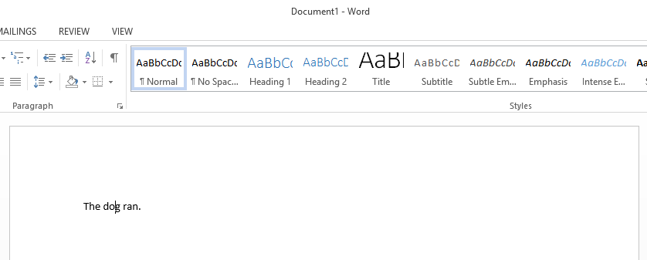

Intense Emphasis applied.

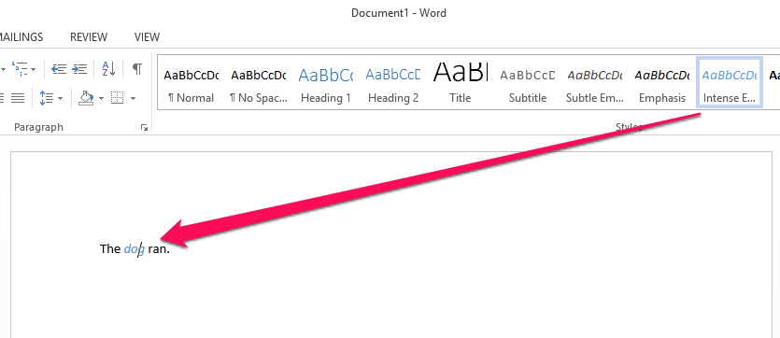

Type 5: Block Quotes
Microsoft Word Styles are also helpful to clearly distinguish third-party content in your manuscript in an effort to avoid licensing conflicts.
By using the Quote style, you can make block quotes in your manuscript stand out by using different-sized text, indenting the quote on each side, and providing space above and below the text. Here’s an example:

Normal body text above. Normal body text above. Normal body text above. Normal body text above. Normal body text above.
Quote example listed here. Quote example listed here. Quote example listed here. Quote example listed here. Quote example listed here. Quote example listed here. Quote example listed here. Quote example listed here. Quote example listed here. Quote example listed here.
Normal body text below. Normal body text below. Normal body text below. Normal body text below. Normal body text below.

If you click within the first and third paragraphs above, you’ll see they have the Normal style applied to them. Click on the middle indented paragraph, and you’ll see it follows the Quote style.
To apply the Quote style to block quotes, place your cursor within the text or highlight the full quote, then select the Quote style in the Styles group.
Note: Do not use the spacebar or Tab key to create indentation for a block quote. Using the spacebar or Tab key creates extra, albeit unseen, characters that will need to be deleted from your manuscript. Your block quote will then require reformatting. Save time and effort by using the Quote style.

Type 6: Figure Tags and Side Box Tags

Figures
You may wish to include figures (images, maps, graphs, tables, or diagrams) in your manuscript. If you do, we ask you do not copy and paste figures directly into Microsoft Word. Instead, place figure tags throughout your manuscript to indicate where figures should be placed. Here’s an example of a figure tag:

<Insert Figure 1.1_Wombat in Narawntapu>

Tips:
- You can select any style to use for your figure tags (or create your own), but be consistent. This will help us (and you) recognize figure tags within the text. In the above example, the character style Figure is applied.
- Be sure to number figures by the chapter or section in which they will appear (e.g. 1.1, 1.2, 1.3, 2.1, etc.). This helps to keep them organized.
- When you include any kind of figure in your text, also include a corresponding in-text parenthetical reference. This way, your readers have a clear understanding of which sentence corresponds to the figure you’ve inserted in the text. Please see the example on page 10 of this document.
- Note: If you can’t find a logical insertion point for a figure reference, ask yourself what value the figure adds to the book.
- Be sure to include the image and its source in your dedicated image log.

Side Boxes
You may also wish to include side box elements in your manuscript. Side boxes can include case studies or real-world examples of a topic covered in the text. Once your book receives full formatting by our team, side boxes will actually appear as boxes. However, while you’re in the process of writing your manuscript, we only need you to mark where you want the boxes to appear. If you wish to include side boxes in your manuscript, include side box tags—similar to figure tags—indicating where they should be placed. Include a tag on either side of the side box text, as shown in the example below.

<Begin Side Box 1.1: Endangered Species in Australia>

Box 1.1: Endangered Species in Australia

Write your side box text here. Most side boxes are less than half a page in length, although there are exceptions. Try to maintain a similar length for each side box in your manuscript. When you’re finished writing your text, add an end tag.

<End Side Box 1.1: Endangered Species in Australia>

Tips:
- You can apply a character style to the side box tags that surround your side box text. In the above example, the style Side Box Tag is applied.
- Ensure your side boxes always have a “begin” and “end” tag so the production team knows where to apply side box formatting.
- As with figures, make sure side boxes are numbered according to the chapter they will appear in.
- As with figures, include an in-text parenthetical reference corresponding to each and every side box. This way, your readers have a clear understanding of which portion of the text is relevant to the information in the side box. Please see the example on page 11 of this document.
- Do not use drawing tools to outline side boxes within your manuscript. Dedicated side boxes will be designed during the production of your text, so drawing them yourself would be extra work!

Advanced/Custom Formatting (optional)
While Microsoft Word has preset styles, you can create your own styles to match your preferences. This guide previously walked you through how to customize the Normal style, but any Microsoft Word Style can be adjusted and customized.
To reformat or create your own style, simply format a bit of text in Word, then highlight it. If you want Heading 1 to look like the formatted text you created, right-click on the Heading 1 button in the Styles group. Then, select Update Heading 1 to Match Selection. See the example below.

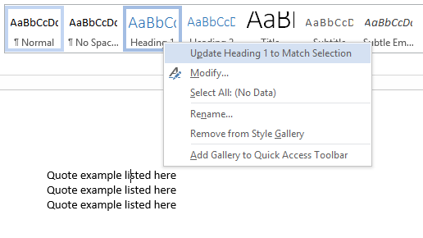

Everything with the Heading 1 style applied will now adopt this formatting. You can do this with any style in your document.

An Example
The sample manuscript beginning on the next page demonstrates proper use of Microsoft Word Styles. We’ve built styles for four levels of headings, a Normal paragraph, list paragraphs, bulleted lists, numbered lists, block quotes (for third-party content), and key words. Click into the various headings and paragraphs to see the styles applied to each one.

Wombats
Wombats are short-legged, muscular quadrupedal marsupials that are native to Australia and are approximately 1 metre (40 in) in length, with short, stubby tails. All are members of the family Vombatidae. They are adaptable in habitat tolerance, and are found in forested, mountainous, and heathland areas of south-eastern Australia, including Tasmania, as well as an isolated patch of about 300 hectares (740 acres) in Epping Forest National Park in central Queensland.

Evolution and taxonomy
Though genetic studies of Vombatidae have been undertaken, evolution of the family is not well understood. It is estimated that wombats diverged from other Australian marsupials relatively as early as 40 million years ago, while some estimates place divergence at around 25 million years.
While some theories place wombats as a miniaturized relative of diprotodonts, such as the rhinoceros sized Diprotodon, more recent studies place vombatiformes as having a distinct parallel evolution, hence their current classification as a separate family.

Characteristics
Wombats dig extensive burrow systems with their rodent-like front teeth and powerful claws (Figure 1.1). One distinctive adaptation of wombats is their backwards pouch. The advantage of a backwards-facing pouch is that when digging, the wombat does not gather soil in its pouch over its young. Although mainly crepuscular and nocturnal, wombats also venture out to feed on cool or overcast days. They are not commonly seen, but leave ample evidence of their passage, treating fences as minor inconveniences to be gone through or under, and leaving distinctive cubic feces.

<Insert Figure 1.1: Wombat in Narawntapu>

Wombats are herbivores; their diets consist mostly of grasses, sedges, herbs, bark, and roots. Their incisor teeth somewhat resemble those of the placental rodents (rats, mice, etc.), being adapted for gnawing tough vegetation. Like many other herbivorous mammals, they have a large diastema between their incisors and the cheek teeth, which are relatively simple.
Wombats' fur can vary from a sandy color to brown, or from grey to black. All three known extant species average around a meter in length and weigh between 20 and 35 kg (44 and 77 lb).
Female wombats give birth to a single young in the spring, after a gestation period, which like all marsupials can vary, in the case of the wombat: 20–21 days. They have well-developed pouches, which the young leave after about six to seven months. Wombats are weaned after 15 months, and are sexually mature at 18 months.
A group of wombats is known as a ‘wisdom.’

Species
The three living species of wombat all reside only in Australia. They are protected under Australian law.

- Common wombat (Vombatus ursinus)
- Northern hairy-nosed wombat or yaminon (Lasiorhinus krefftii)
- Southern hairy-nosed wombat (Lasiorhinus latifrons)

Human Relations

History
The name 'wombat' comes from the now nearly extinct Darug language spoken by the Aboriginal Darug people who originally inhabited the Sydney area. It was first recorded in January 1798, when John Price and James Wilson, a white man who had adopted Aboriginal ways, visited the area of what is now Bargo, New South Wales. Price wrote:
We saw several sorts of dung of different animals, one of which Wilson called a Whom-batt, which is an animal about 20 inches high, with short legs and a thick body with a large head, round ears, and very small eyes; is very fat, and has much the appearance of a badger.

Spelling Variations
Wombats were often called badgers by early settlers because of their size and habits. Because of this, localities such as Badger Creek, Victoria, and Badger Corner, Tasmania, were named after the wombat. The spelling went through many variants over the years, including 'wambat', 'whombat', 'womat', 'wombach', and 'womback', possibly reflecting dialectal differences in the Darug language.

<Begin Side Box 1.1>

Side Box 1.1 – Endangered Species in Australia

There are over forty endangered species of mammal in Australia. Four of those species are critically endangered. The four critically endangered species are listed below:

- Gilbert's potoroo, Potorous gilbertii
- Christmas Island pipistrelle, Pipistrellus murrayi
- Bare-rumped sheathtail bat, Saccolaimus saccolaimus nudicluniatus
- Southern bent-wing bat, Miniopterus schreibersii bassanii

<End Side Box 1.1>

Time to get writing!
We hope this guide to building your manuscript using Microsoft Word Styles has been useful to you. Please feel free to reach out to your project editor with any questions about Word Styles.
When you’re ready to start writing, you can use the template provided by your project editor to begin your first chapter!

