Template for Discussions
Chapter number:
Discussion Title (optional, default is Ch # Discussion):
Options (optional, defaults are listed below)
Allow threaded replies: Yes
Users must post before seeing replies: Yes
Graded: Yes
Allow liking: No
Discussion Instructions:

EXAMPLE 1:
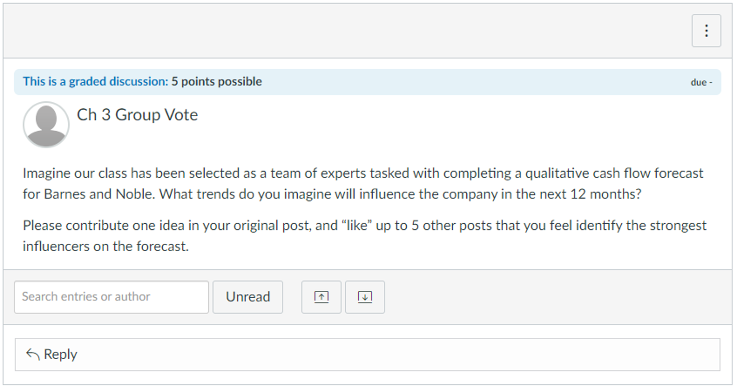
What you need to submit:
Chapter number: 3
Discussion Title: Group Vote
Options (optional, defaults are listed below)
Allow threaded replies: Yes
Users must post before seeing replies: Yes
Graded: Yes
Allow liking: Yes
Discussion Instructions:
Imagine our class has been selected as a team of experts tasked with completing a qualitative cash flow forecast for Barnes and Noble. What trends do you imagine will influence the company in the next 12 months?

Please contribute one idea in your original post, and “like” up to 5 other posts that you feel identify the strongest influencers on the forecast.

