Discussion Board Template

A discussion board is an asynchronous discussion form completed online. Students will be able to write their own initial posts, read classmates’ posts, and respond to the different threads in each forum.

We recommend writing a structured prompt that includes the following:

1. Directions for writing an initial post that include an open-ended question or idea to address, along with a word count target
2. Directions for writing 1 - 2 peer response posts that extend the digital conversation in a meaningful way

Please notify your project editor if you would like the discussion forum settings to be adjusted from the default settings, which are listed below:

* *Allow threaded replies:* Yes
* *Users must post before seeing replies:* Yes
* *Graded:* Yes
* *Allow liking:* No

# Chapter #

Discussion Title (optional, default is Ch # Discussion):

Discussion Instructions:

Instructions for initial discussion post:

Write the open-ended prompt here.

* List each component or follow-up question separately.
* Word count range: # - # words

Instructions for response post(s):

Respond to # peers….

### EXAMPLE:

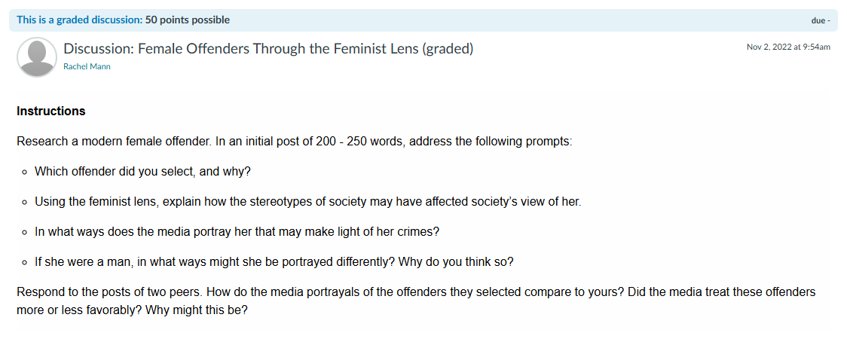

**What you need to submit:**

Discussion Title: Female Offenders Through the Feminist Lens

Discussion Instructions:

Research a modern female offender. In an initial post of 200 - 250 words, address the following prompts:

* Which offender did you select, and why?
* Using the feminist lens, explain how the stereotypes of society may have affected society’s view of her.
* In what ways does the media portray her that may make light of her crimes?
* If she were a man, in what ways might she be portrayed differently? Why do you think so?

Respond to the posts of two peers. How do the media portrayals of the offenders they selected compare to yours? Did the media treat these offenders more or less favorably? Why might this be?

# Chapter 1

Discussion Title (optional, default is Ch # Discussion):

Discussion Instructions:

Instructions for initial discussion post:

Write the open-ended prompt here.

* List each component or follow-up question separately.
* Word count range: # - # words

Instructions for response post(s):

Respond to # peers….

# Chapter 2

Discussion Title (optional, default is Ch # Discussion):

Discussion Instructions:

Instructions for initial discussion post:

Write the open-ended prompt here.

* List each component or follow-up question separately.
* Word count range: # - # words

Instructions for response post(s):

Respond to # peers….